Instructions to Setup and Run

Da Vinci MAL Application

Below are the instructions to setup and run the Da Vinci MAL application

Prerequisites:

1. Java 8
2. Apache Tomcat 7 or 8
3. PostgresSql Database 10.x
4. Maven 3.3.x
5. GIT
6. NodeJS 12.4.1

# Clone the Repository

Clone the respository using the below command in command prompt

git clone <https://github.com/HL7-DaVinci/atr.git>

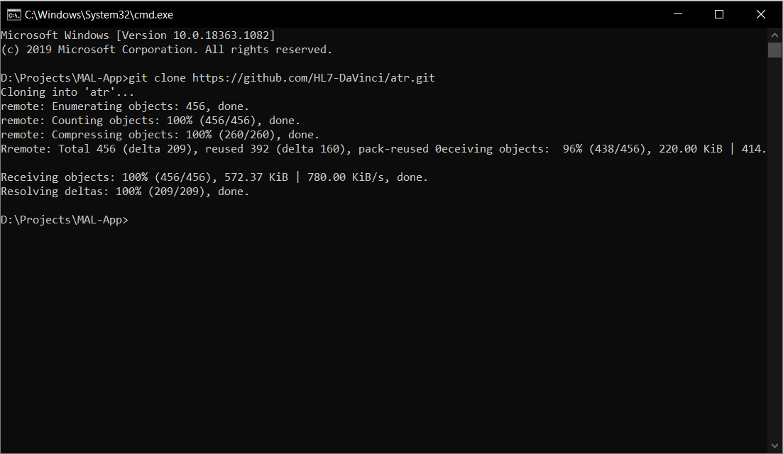

# Installation Instructions

## Postgres Configuration:

Load Schema and data into database

Create the database by running the below command in command prompt. Enter the password for postgres database when prompted. Default password will be ‘postgres’

$ createdb -h localhost -p 5432 -U postgres <database_name>

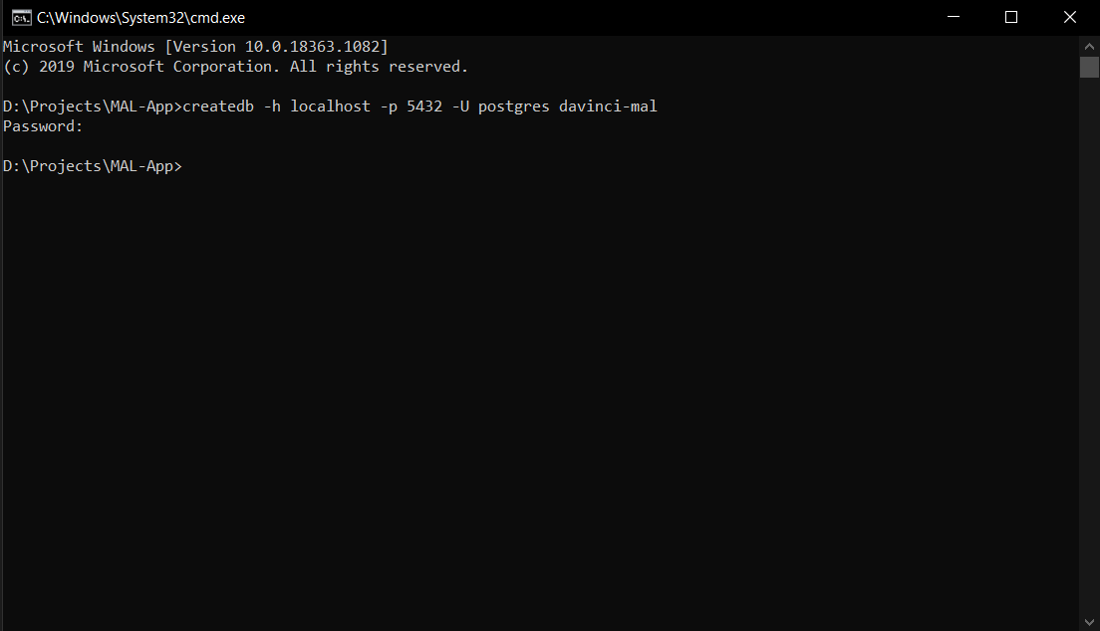

Database file bulk-r4.sql will be in the cloned repository. Load Schema and data using the below command.

$ psql -U postgres -d <database_name> -f <Path to cloned repository>/bulk-r4.sql

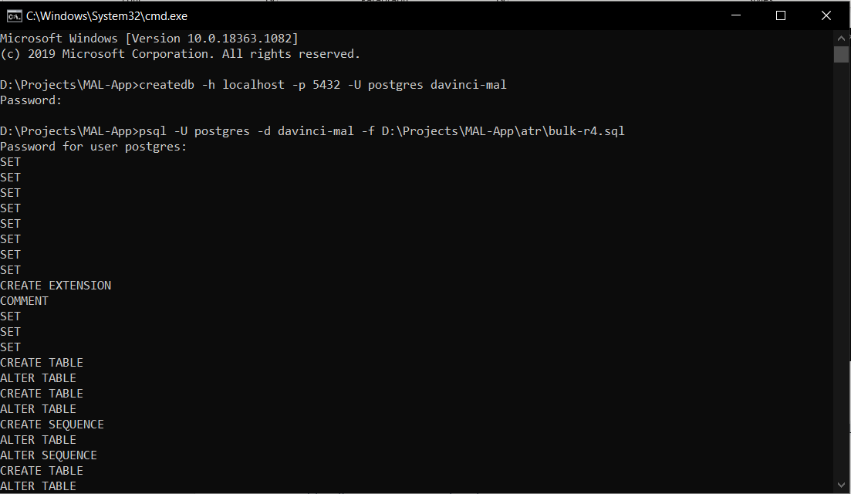

## Create Build:

### Build Bulk FHIR Server Backend Service:

Change the database configurations in the file application.properties located under src/main/resources

jdbc.url=jdbc:postgresql://localhost:5432/<database_name>

jdbc.username=<username>

jdbc.password=<password>

Then navigate to backend service directory `/atr/Server/davinci-bulk-fhir-server` and run Maven build to build application war file.

$ mvn clean install

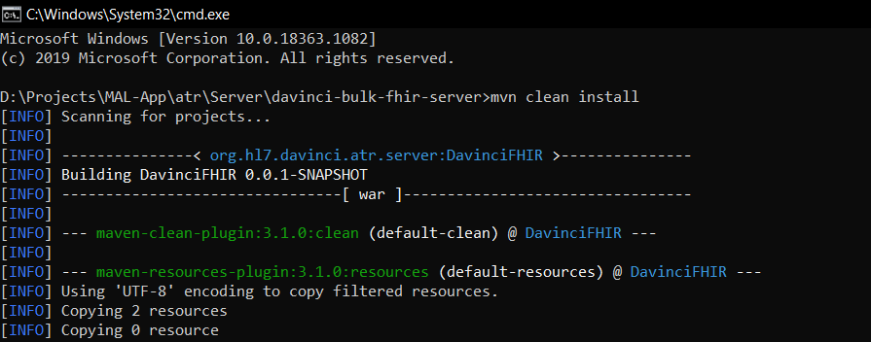

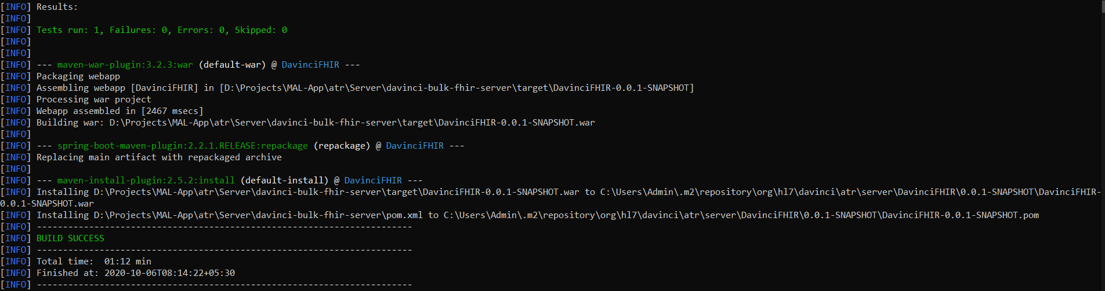

This will generate a war file under target/DavinciFHIR.war. Copy this to your tomcat webapp directory for deployment.

##### Start Tomcat Service

If the tomcat is started successfully then you should be able to access below endpoints

GET END POINTS:

1.http://localhost:<tomcatport>/<Service_name>/fhir/Group/1/$export?_type=Patient,Practitioner,Organization,Location,Coverage,RelatedPerson,PractitionerRole --Extracts all the Patients from the given Group.

2.http://localhost:<tomcatport>/<Service_name>/fhir/Group/2/$export?_type=Patient,Practitioner,Organization,Location,Coverage,RelatedPerson,PractitionerRole --Extracts all the Patients from the given Group.

Request Headers:

1. Prefer: respond-async

2. Content-Type: application/fhir+json

The above requests will provide the Content-Location in Response Headers

Response Headers:

1. Content-Location:http://localhost:<tomcatport>/<Service_name>/bulkdata/<JobId>

### Polling to Content-Location

Method: GET

URL: [http://localhost:<tomcatport>/<Service_name>/bulkdata/<JobId](http://localhost:%3ctomcatport%3e/%3cService_name%3e/bulkdata/%3cJobId)>

Response Body:

{

    "transactionStartTime": "Thu, 16 Jan 2020 07:16:42 UTC",

    "request": "http://localhost:<tomcatport>/<service_name>/fhir/Group/1/$export",

    "secure": "false",

    "output": [

        {

            "type": "Patient",

            "url": "http://localhost:<tomcatport>/<service_name>//bulkdata/download/41/Patient.ndjson"

        }

………

    ]

}

### Download the NDJson files:

Method: GET

URL: http://localhost:<tomcatport>/<service_name>/bulkdata/download/41/Patient.ndjson

Response Body: <JSON Object with list of Patients>

### Update data in database:

Please follow the below instructions to create and update the records in database.

1. In Windows open the pg_admin tool and select the database.
2. Expand <database_name> 🡪 schemas 🡪 public 🡪 Tables. A list of tables will be displayed.
3. Right click on a table and select the View data option to view the data.
4. The Actual resource JSON data will be under the column ‘data’.
5. Double click on the row column ‘data’ and update the JSON object.
6. Click on Save button on top of the table to save the changes.

## Run MAL Client Application

Run the below command to build the frontend application. Navigate to Directory /atr/client and run the below command

npm install

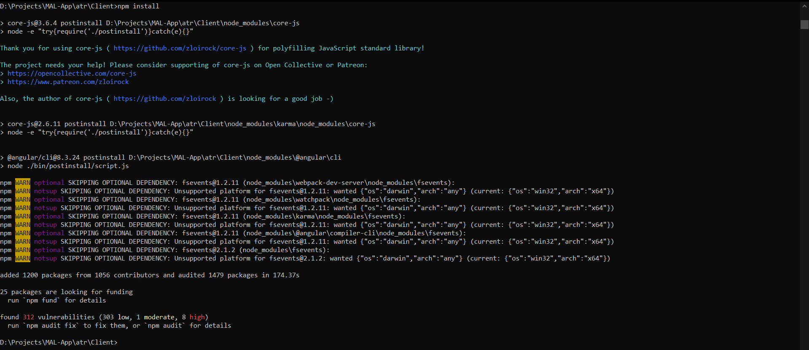

Run the below command to start and run the MAL client

npm start (or) ng serve

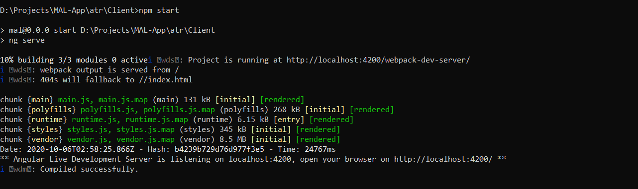

Open the browser and enter the URL ‘http://localhost:4200’ to access the MAL Client.

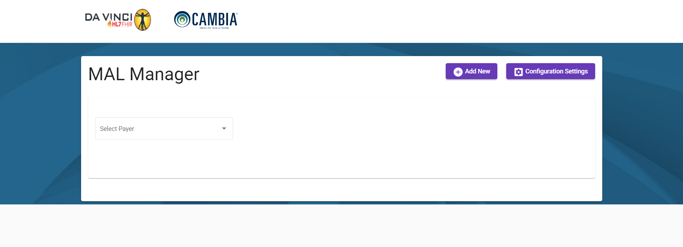

Click on Configuration Settings and enter the values as shown in the below image and click on Save button

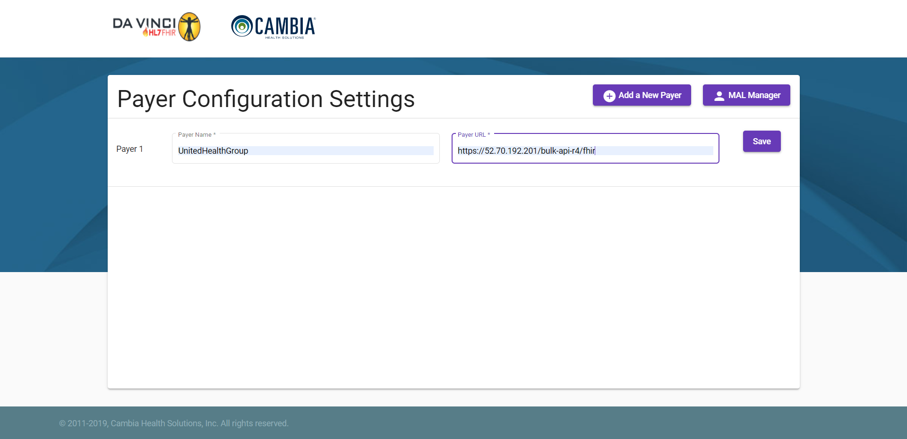

Then Click on ‘MAL Manager’ button and select the Payer configured in Configuration Screen. Then Select the Discover the Group resource by selecting any one of the radio buttons displayed and enter the value as shown in the below image.

After entering the values click on Discover MAL button. The client will make an API call to get the Group resources based on the values entered and the Group information will be displayed in the table as shown below.

Then Click on Download button to download the Patients data attributed in the Group resource. Once the data is downloaded, the Download button is greyed out and View button will be enabled.

Click on View button to view the Patient data in the tabular format as shown in the below image.

